LA LAGUNA DEL SOLDADO / THE SOLDIER’S LAGOON
Dir: Pablo Álvarez Mesa

Country and Year of Production
COLOMBIA, CANADA 2024
Runtime
76 MINUTES
Tech Format
16MM, COLOR, 1.33 (4:3)
Screening Formats
DCP, DIGITAL FILE, 5.1
Language
SPANISH with ENG. and FR. Subs Srt

CREDITS
Director, Producer, Editing, Cinematography
Pablo Álvarez Mesa
Sound recording, Production Assistant
Erin Elizabeth Ryan
Sound Editing
Alex Lane
Pablo Álvarez Mesa
Sound Mix
Alex Lane
Percussion
Stefan Schneider
Recording Engineer
Michael Feuerstack
Subtitles
Sally Station
Charlotte Selb
Post production Coordinator
Nguyen-Anh Nguyen
Colour Grading
Marc Bourcot
Project Coordinator
Marianne Vargas
Online Editor
Thomas La Ley
Post Production Technician
Clarence De Bayser
Poster
Dylan Haley

Festivals
Pascale Ramonda
pascale@pascaleramonda.com
LA LAGUNA DEL SOLDADO / THE SOLDIER’S LAGOON
Dir: Pablo Álvarez Mesa

One-Liner
200 years after Simón Bolívar’s liberation campaign across Colombia, The Soldier’s Lagoon retraces The Liberator’s journey across the high-altitude marshlands while searching for glimpses of his ghost still present in this historically contested territory.

Short Synopsis
200 years after Simón Bolívar’s liberation campaign across Colombia, La Laguna del Soldado retraces The Liberator’s journey across the high-altitude marshlands while searching for glimpses of his ghost still present in this historically contested territory. Reflecting on the construction of historical narratives and their environmental repercussions, La Laguna del Soldado traverses the páramo, a living and elusive archive, navigating through the dense fog suspended between Simon Bolivar’s past and Colombia’s present.

La Laguna del Soldado is the second in a three-part series of films exploring the intersection of oral narratives, political outcomes, and the territories marked by Simón Bolívar’s passage during the Liberation Campaign of Colombia in 1819. The first completed part is Bicentenario (2021).

Long Synopsis
Two hundred years after Simón Bolívar’s liberation campaign, La Laguna del Soldado retraces “the Liberator’s” journey across the high-altitude marshlands of the páramo in search of glimpses of his ghost in the historically contested territory. Creatively intersecting traditions of landscape film, oral history, and political essay, the film cinematically reveals the collision of history and myth inscribed in the land of what would become an inevitable failed state–the Great Colombia.

La Laguna del Soldado traverses the páramo region, an inhospitable and mythical landscape high in the Eastern Colombian Cordillera, which Bolívar crossed with his army in a daring strategy regarded as the turning point of the Liberation movement. Embracing the páramo’s subtle but expressive natural rhythms, the film poetically explores intersecting socio-historical legacies of Bolivar’s Liberation Campaign and environmental perspectives of the páramo’s unique wetland ecosystem. The conjunction of political events and the ecosystems that host and participate in them reveal the current socio-political tensions embedded in the territory.

Shot in 16mm film, with acute emphasis on formal experimentation and sound design, the film interweaves the misty landscape with impressionistic accounts of its inhabitants, including a retired military man who recounts his battles against the guerrillas in the páramo, local artists transforming clay into art, and a group of ornithologists studying bats and hummingbirds but revealing the interconnection between the conflict and their research. These diverse voices unite time and sensibilities in the unique ecosystem, bridging historical and contemporary myths that inhabit and define the land.

La Laguna del Soldado is the second in a three-part series of films exploring the intersection of oral narratives, political outcomes and the territories marked by Simón Bolívar’s passage during the Liberation Campaign of Colombia in 1819. The first completed part is Bicentenario (Berlinale Forum Expanded 2021).

Director’s Statement
Following Bolívar’s path into the high Andean mountains of Colombia, La Laguna del Soldado encounters a rich, but fragile hydraulic ecosystem that serves as a backdrop for oral histories that have been silenced by deep-rooted violence in the region.

Dubbed “the land of the mist” by Spanish Conquistadors, the páramo ecosystem exists only in high altitude mountains in the tropics. More than 60% percent of the world's páramos thrive in Colombia, where they are a major source of water for the country. Healthy páramos are covered with Frailejones, a plant adapted to the extreme conditions of high-altitude tropics, where scorching sun is followed by freezing nights. The plants capture water from thick rolling fogs and rains, which are then trapped and slowly released by rich peat soils, preventing floods in the wet season and drought in the dry months.The symbiotic relationship between the Frailejon and the absorbing soil creates water out of thin air, which continues downstream, feeding rivers, aquifers, and water catchment areas. The páramo that Bolivar crossed during his Liberation Campaign is the source of Colombia’s two largest rivers: the Orinoco and the Magdalena.

On June 4, 1819 Bolívar embarked on a six week journey from the Arauca river on the border of Colombia and Venezuela, through the high Andean páramo, to Bogotá. The 10th of August 1819 marked the end of this journey; by then, Bolívar had liberated Colombia, claiming the title of “El Liberator.” On his quest to conquer Bogotá, Bolívar led his troops through the páramo’s rugged terrain against their will. The troops, who came from the hot lowlands, were unprepared for the extreme altitude and freezing temperatures. Bolívar nevertheless carried out his assent into the impenetrable ecosystem, which the Spanish Armies never imagined anyone would dare to attempt. Many troops died of hunger and cold during the treacherous three day crossing. Their remains were unceremoniously dumped in a lake that is the source of one of Colombia’s main rivers. Today, this lake still bears their name—the Soldier’s Lagoon.

Its experimental treatment reflects on the weight of history in the territory, revealing a tight-knit relationship between land and violence that is traced back to Bolívar’s political legacy and the violent seeds planted during the country’s Independence. The path Bolívar took for his crossing was recently used by armed groups including the guerrillas who controlled the area for over 50 years. The sensory meditation unearthes the afterlives of violence that linger in the country’s waterways, providing a surface to engage with the past and its life in the present.

Speculative and mystical in tone, La Laguna del Soldado traverses an ancestral path of the Muisca people. Bodies deep in the lagoon feed the country’s rivers the remnants of our past: the bloody Colombian veins. Intertwining azure-toned images and infra-sound from within the lagoon’s depths, the cinematic revery is also a demand to care for a rare and fragile ecosystem threatened with disappearance. La Laguna del soldado explores an elusive living archive, navigating through the dense fog suspended between Bolívar’s past and Colombia’s present.

How does a country internalize trauma and how is it reproduced across generations? How can we coexist in a territory that is both a threat due to its endemic violence and the very source of life? Immersing viewers in the liminal space of the páramo—between past and future, in a region that has been the site of a daring military passage that led to successful wars of liberation—the film cuts a path through the fog.

Pablo Alvarez Mesa - Biography
150 words
Pablo Alvarez-Mesa‘s films have played at international film festivals including Berlinale, IFFR, MoMA Doc Fortnight, Visions du Réel, and RIDM. His most recent film, Bicentenario, explores Simón Bolívar’s battles of Independence, and was played at the 2021 Berlinale, MoMA Doc Fortnight and Viennale, among other festivals. It earned a Jury Mention at Festival Punto de Vista in the Main Competition. Pablo is also a cinematographer and editor and is currently editing with Sofia Bohdanowicz her new feature film Opus 28.

Pablo’s latest film, The Soldier's Lagoon was recently awarded with The Docs in Orbit Invitation Award at the Docs in Progress showcase at Festival de Cannes. Pablo's interest in documentary lies in the relationship between facts and fiction; between what is recalled and what is inevitably constructed. His films touch in one way or another, issues of displacement, history and collective memory.

90 words
Pablo Alvarez-Mesa is a filmmaker, cinematographer and editor working mainly in non fiction, whose films have played and earned awards at international film festivals including Berlinale, IFFR, Viennale, MoMA, Visions du Reel, and RIDM. His work in cinema lies in the relationship between fact and fiction; between what is recalled and what is inevitably constructed. Pablo is Sundance Doc Fund grantee, an affiliate member of the Centre for Oral History and Digital Storytelling at Concordia University, and a Berlinale Talents, Banff Centre for the Arts and Canadian Film Centre alumnus.

50 words
Pablo Alvarez-Mesa is a filmmaker, cinematographer and editor whose films and collaborations have played and earned awards internationally. Pablo is an affiliate member of the Centre for Oral History and Digital Storytelling at Concordia University, and a Berlinale Talents, Banff Centre for the Arts and Canadian Film Centre alumnus.

Selected Filmography
The Soldier’s Lagoon 2024 (75min 16mm)
Infinite Distances 2022 (25min HD)
Bicentenario 2021 (45min 16mm)
La Pesca 2017 (23min HD)
Speaking into the Air 2014 (22min HD)
Jelena’s Song 2011 (33min 16mm)
Presidio Modelo 2010 (16min DV)

Context Piece - Our Violent Hydrocommons
by Gwynne Fulton
The world is not one. Like water itself, worlds are irreducibly plural. The understanding that there is a single reality in front of us—a “one-world world”—is neither universal nor natural; as Colombian anthropologist Arturo Escobar argues, it is the result of a particular history for which the Conquest of America serves as a pivotal index. Water extractivism, in all its varied forms, continues this occupation of territories by a world that gives itself the right to assimilate local realities in the name of the “common good” of progress. Water privatization, pipelines, and large-scale infrastructures that bury and contaminate bodies of water are the ongoing legacy of the colonial doctrine of terra nullius, which actively produces space for the expansion of a one-world world, by making absent other worlds.
Contemporary struggles to defend water across Turtle Island/Abya Yala are also struggles for worlds. The Soldier’s Lagoon participates in these struggles by inviting the recovery of alternate ways of relating to water and to others in the wake of intersecting forms of violence that forcefully disappear worlds. Shot on 16mm, the experimental nonfiction film by Tiohtià:ke/Montréal-based filmmaker Pablo Alvarez Mesa, engages the hydrology of the Andean páramos—high-altitude grassland ecosystems that are the headwaters of many of Colombia’s rivers, where frailejones—a plant species endemic to the region—channel water from the sky into the rich tropical soils.
Tracing waterways from the Páramo de Pisba through rivers and urban channels, the film engages a double process that Escobar calls “ontological politics.” Calling our attention to the ontology of the neoliberal globalizing project of world markets that actively produces the disappearance of worlds, it performatively enacts the endurances of ancestral water-worlds across the Altiplano Cundiboyacense in the ancient lands of the Muisca people, whose territory was traced by the system of paths that water took across the sky, the earth’s surface, the infraworld. The film’s sensory investigation of the páramo is part of a reparative justice process that recognizes watery territories as victims of the decades-long armed conflict.
The Soldier’s Lagoon examines the violence of the hydrocommons. Mobilizing water’s materiality, Astrida Neimanis’ concept of the “hydrocommons” describes a shift from individualistic ways of conceiving identity toward a more relational approach. Her “wet ontology” is grounded in the fluids that are shared—however asymmetrically—between our watery bodies. We share a common history in our watery beginnings, she argues, even though “we are not all equally adrift.” To negotiate these relations, she proposes a practice, an ethics, and a poetics of a radically embodied hydrocommons. Thinking about leaky bodies of water “in common” offers an ecopolitical alternative to dominant globalized economies and cultures of water.
But the hydrocommons is not without its turbulent undercurrents. Its aim of recognizing fluid continuities across watery bodies sits close to the homogenizing project of the one-world world that erases alternatives. This is the darker side of the commons, which becomes common only by expelling experiences that do not conform to a dominant Eurocentric worldview. Examining the relations among rivers, political violence, and historical memory, Alvarez Mesa traces the currents of political violence back to the place where rivers are born. His film is the second part of a trilogy about the legacies of Simón Bolívar’s 1819 liberation campaign. It retraces the path of Bolívar’s troops from the plains to the Páramo de Pisba in the Eastern Cordillera of the Andes, where the revolutionary forces encountered freezing rains and dense fog as they tried to reach Santa fé de Bogotá, in a daring military feat that sealed the independence of Colombia from the Spanish Crown.
The film registers floating rivers of mist as they condense into waters, irrigating the soils and accumulating in lagoons long considered sacred by the Muisca people, before spilling down into the Arzobispo and Cravo Sur rivers that provide water to the Orinoco River basin. “They were dumped here,” the voice tells us. “There is a lot of pain in these mountains.”
The film is a study of place: anchored high in the Andean marshlands, a monument marks a mass grave in the clouds where the revolutionary army disposed of hundreds of troops who succumbed to cold and hunger during the crossing. The monument tries to hold the dead to their place. But water is slippery, intrinsically unpredictable, irreverent of boundaries. Alvarez Mesa draws on water’s spectral materiality to attend to the dead that haunt Colombia’s waterways—a country where, to this day, rivers are the cemeteries for countless victims. What happens to our watery bodies when rivers are made to circulate violence?
Shot in azure tones, Alvarez Mesa’s cinematic portrait of this hydraulic territory unsettles the hydrocommons—showing us its underflow. The film goes searching for spectres, invoking multiple temporalities of violence. It conjures Bolívar’s ghost to hold him accountable for the patrimony of violence he unleashed in his liberation campaign, linking it to the present state of ecological and political violence. It observes the ways that violence, when left untended, is encrypted in bodies, and diffused across generations and geographies. Black studies scholar Christina Sharpe describes the ocean as an archive that is still animated by slavery and the antiblackness that persists in its wake, but Alvarez Mesa finds the waterways of Colombia teeming with the dead that leak out of this mass grave: the decomposing bodies of these dead soldiers become the nutrients that cycle through the lagoons into rivers. We are drinking them. He develops his analogue film in them. In this way, the violent acts at the foundation of the nation get incorporated into bodies and into the body politic. This, too, is a form of the hydrocommons: “When violence is the form under which people share their world,” writes Ariella Aïsha Azoulay in Potential History, “violence is the form the commons take.” Neimanis is right that the commons “does not stop at our skin.” La laguna del soldado’s spectral ontology shows this to be truer still. In territories still marked by coloniality, the hydrocommons gestates violence.
The Soldier’s Lagoon evokes the strange temporality of the páramo. It interweaves overlapping layers of history: the 1538 arrival of Spanish conquistadors in Muisca territories in search of the mythical El Dorado and the 1819 independence from Spain, when Criollo elites that assumed power proclaimed the universal rights of man while reinstating the same caste distinctions of the colonial model. As rivers are buried below the city, the water-beings disappear. These discrete temporalities of violence converge and condense in Alvarez Mesa’s sensory study of the páramo. In revisiting these violent conjunctures, the film quietly but unequivocally goes about unlearning our violent hydrocommons. It traces an intimate psycho-geographic territory of resistance for what Sharpe calls “wake work”—a mode of inhabiting and reimagining life in the wake of violence.
The film negotiates strategic alliances between heterogeneous actors in a world where many worlds fit: environmentalists, ex-combatants, campesinos, Muisca descendants, and the dead, who are being recycled through water infrastructures. A group of ecologists archiving the infrasounds of bats work with communities to form strategic alliances to defend water. Peasant coal miners describe their heirloom operations as a form of resistance against regulated, corporate extraction. An ex-soldier seeks reconciliation with himself and with the land by replanting the frailejones that were once harvested by troops who made beds from their warm, furry leaves. What the film makes present is “not a plurality of views of a single world, but a single view of different worlds.” Collectively these divergent actors cultivate intimate relationships with the páramo by studying and caring for it, exemplifying what Peruvian anthropologist Marisol de la Cadena calls “uncommoning”—a mode of producing a commons in divergence. Their voices describe multiple ways of seeing, knowing, and protecting the territory.
Reflecting on the hidden, which is given as much reality as the visible, the film’s sound and image submerge us into the lagoon. Underwater, it invents another outcome for the sunken. Combining structuralist/materialist techniques with a sensitivity to landscape, a sequence of colour permutations opens a visual and sonorous bifurcation of time that feeds back through my watery body, reminding me that I too am gestating these cycles of violence fed by the Global North’s insatiable demand for “resources”—in this case visual, intellectual, spiritual. For a film that deals with violence, The Soldiers Lagoon is poetic, slow, and observational. Its fluid dissolves and flares move with the mists to build surfaces and strategic opacities that obstruct my vision. The water enacts its own magical resistance: not even images, it says, can be extracted from these sacred lands where the Muisca buried their dead, “Because here is the origin of everything—the origin of water.” Its audiovisual poetics of liquidity plumbs the undertows of violence. But the film is ultimately turned to the future, to the demand of entangled water-worlds for temporal, ecological, and racial justices to come that necessarily exceeds the present.
Ruminative and ruggedly beautiful, the film’s somatic historiography of the páramo unsettles the hydrocommons. Its wet hauntology elucidates the cycles of violence that produced the Muisca world as nonexistent. It reflects on the colonial forces that flow through Colombia’s image of itself as a nation, from the independence led by elite Criollos, through the turbulent period of the civil wars, to the present conflict that drinks from the very waters it uses as its grave. At the same time, it recovers the relational worlds of the páramo. Engaging the present absence of the dead, The Solider’s Lagoon gives viewers an opportunity to feel other worlds submerged in the open waterways of Colombia. At once poetic and political, this act begins to regenerate a relationship with water, with the lagoons and the fog that they invite into the camera, and the pains they hold, through a durational process of walking, observing, and listening.

- A longer version of this text appeared in Esse art + opinions no 109: Water (fall 2023): https://esse.ca/en/nos-hydro-communs-violents/

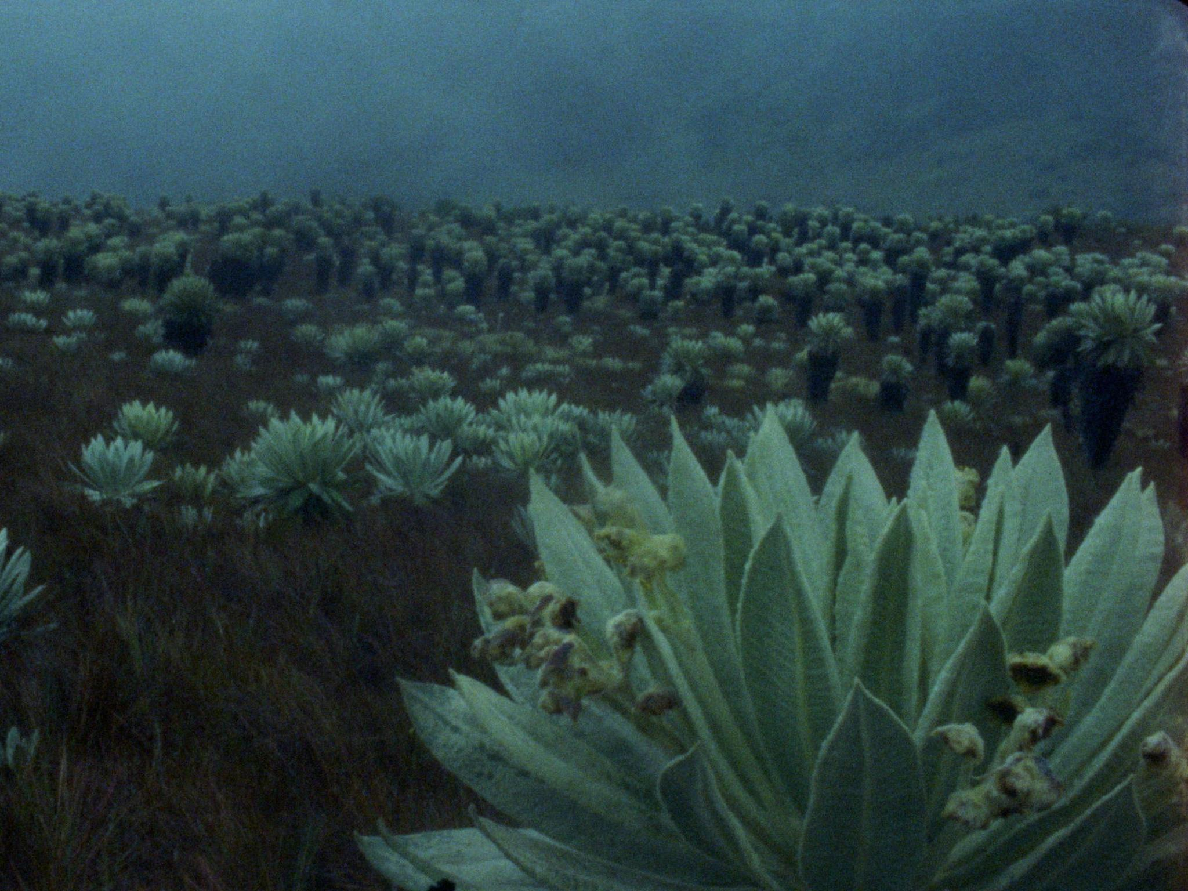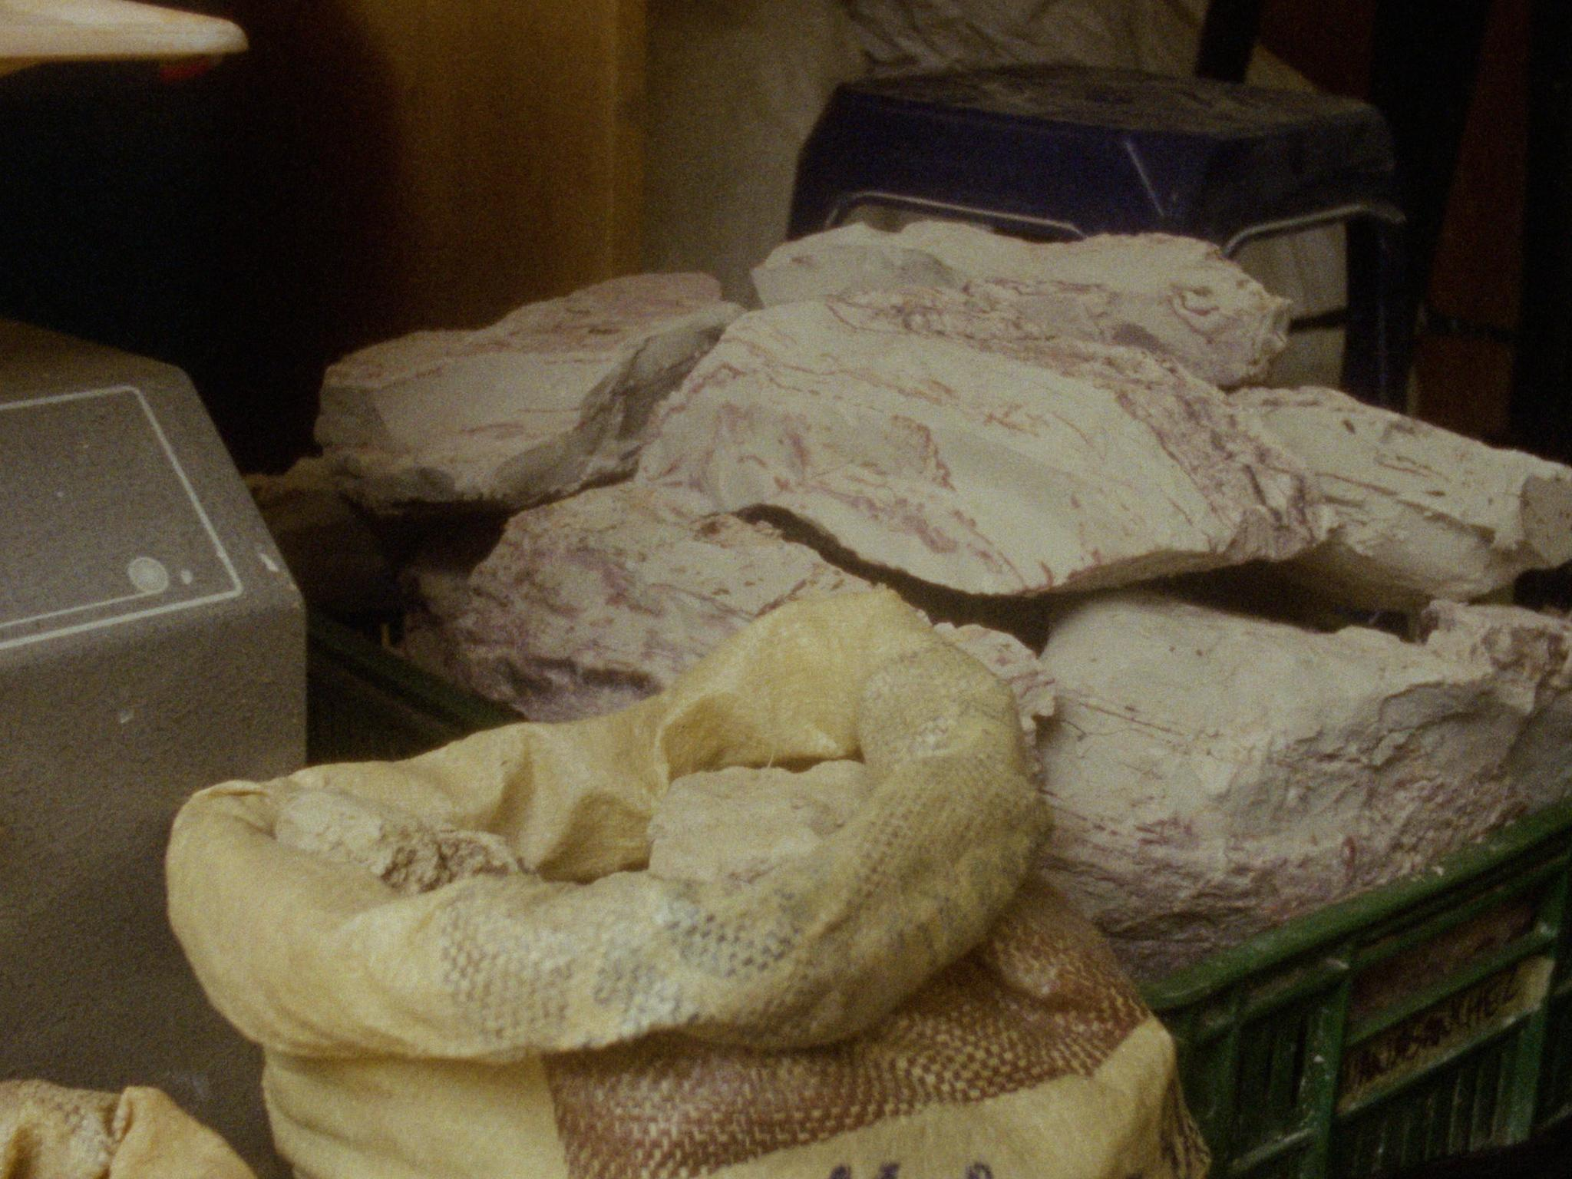
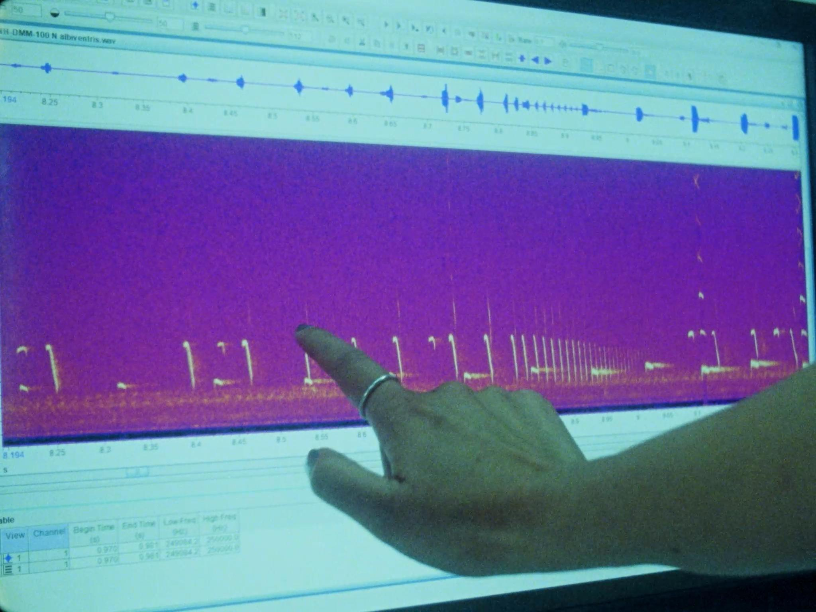
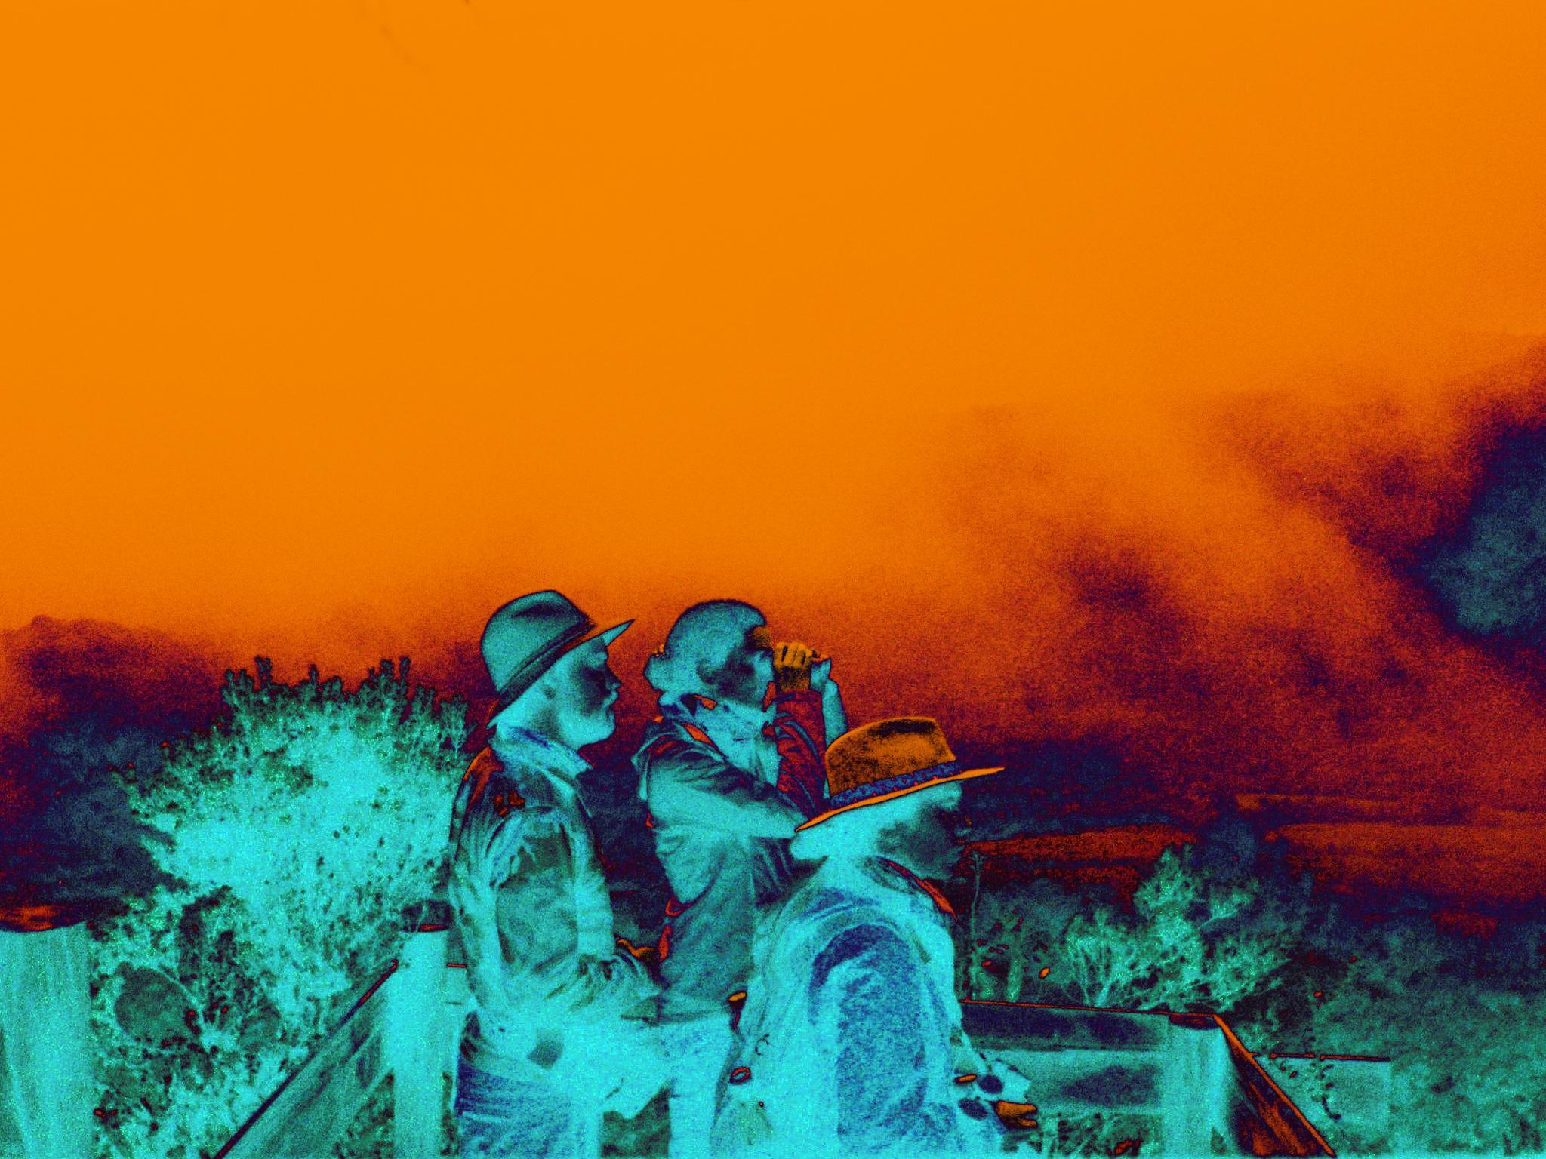
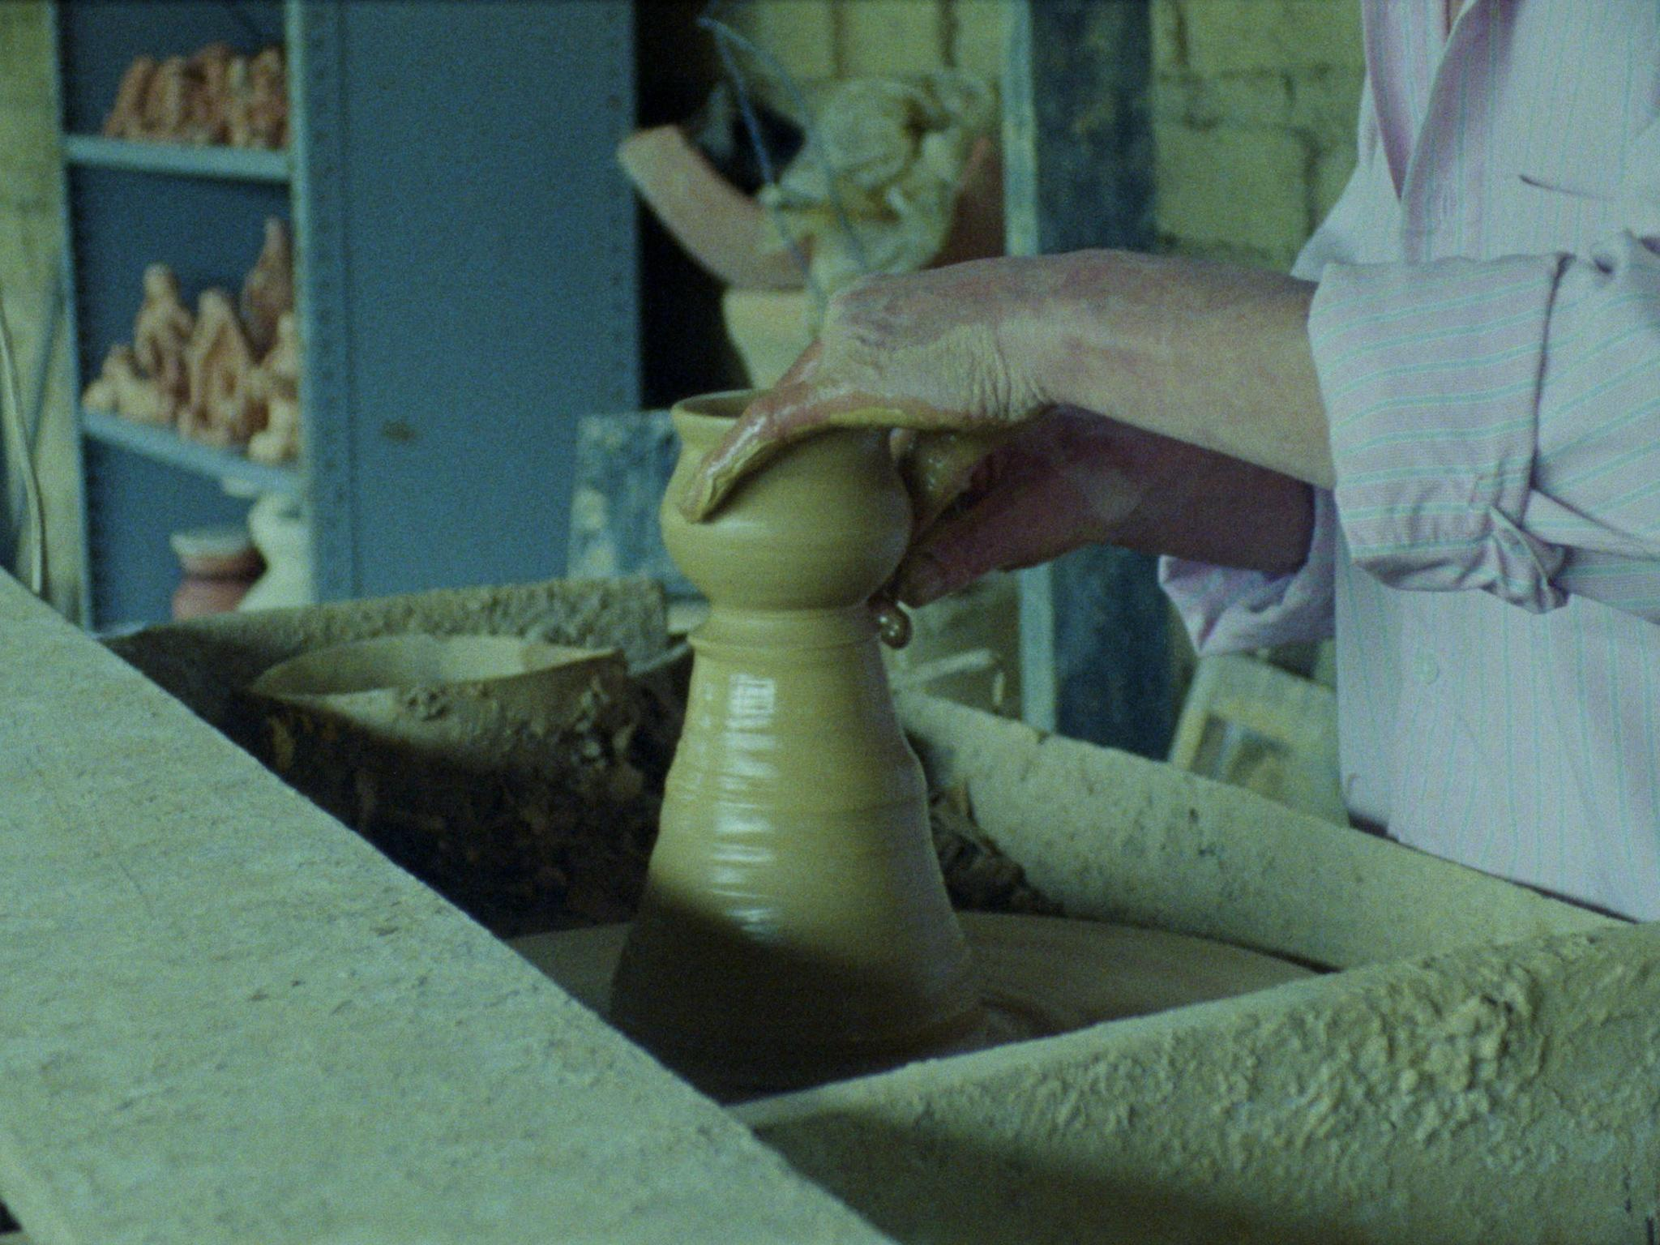
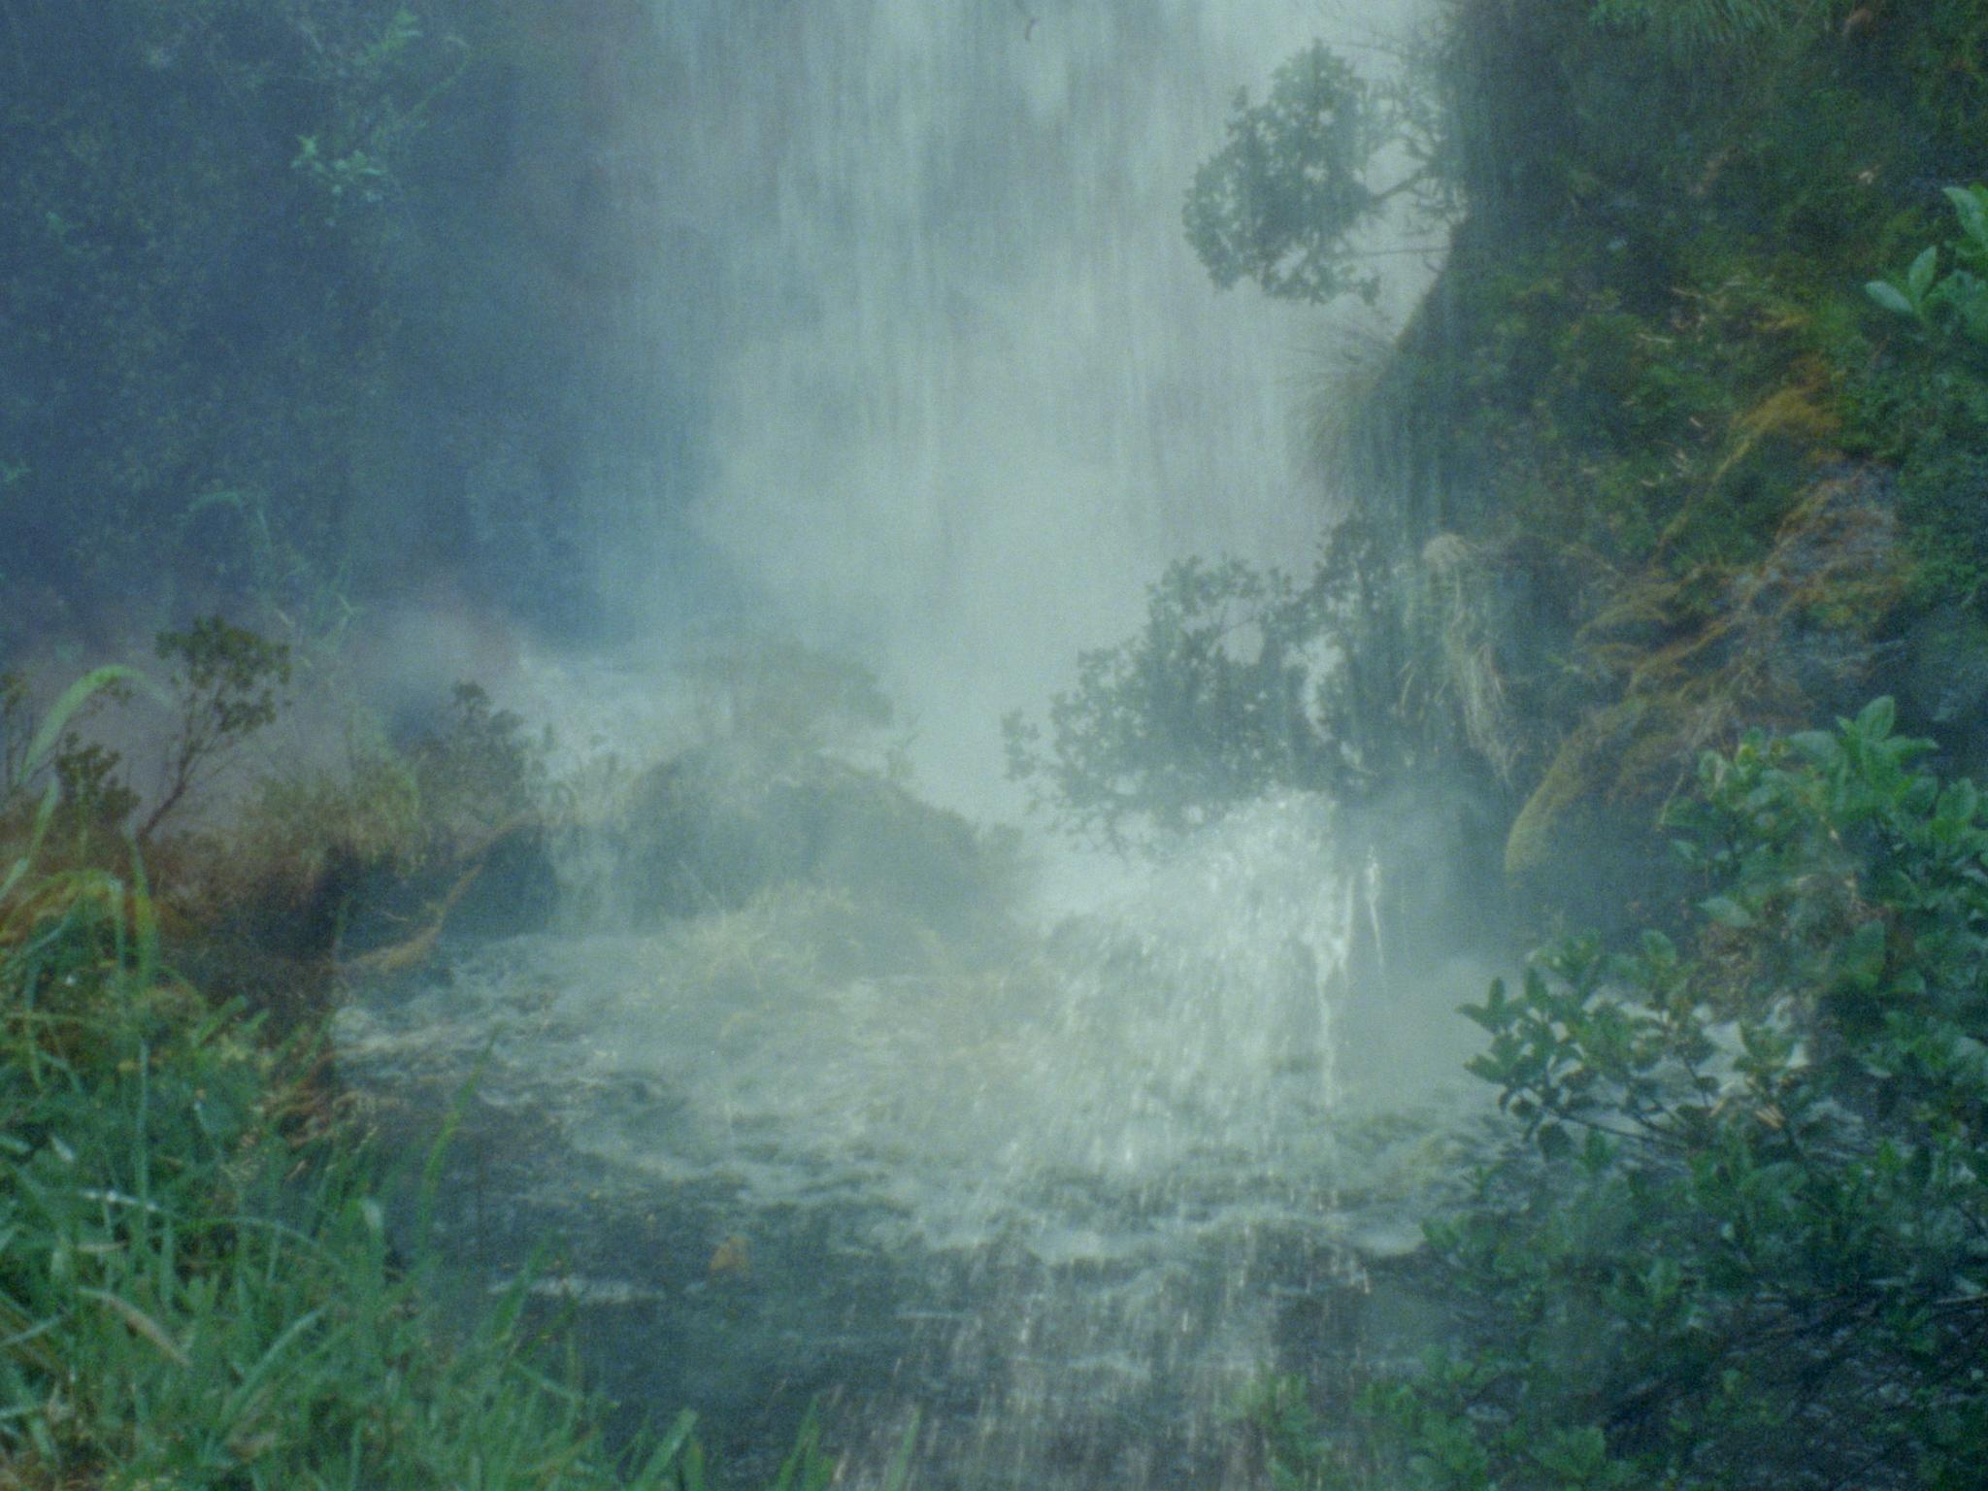
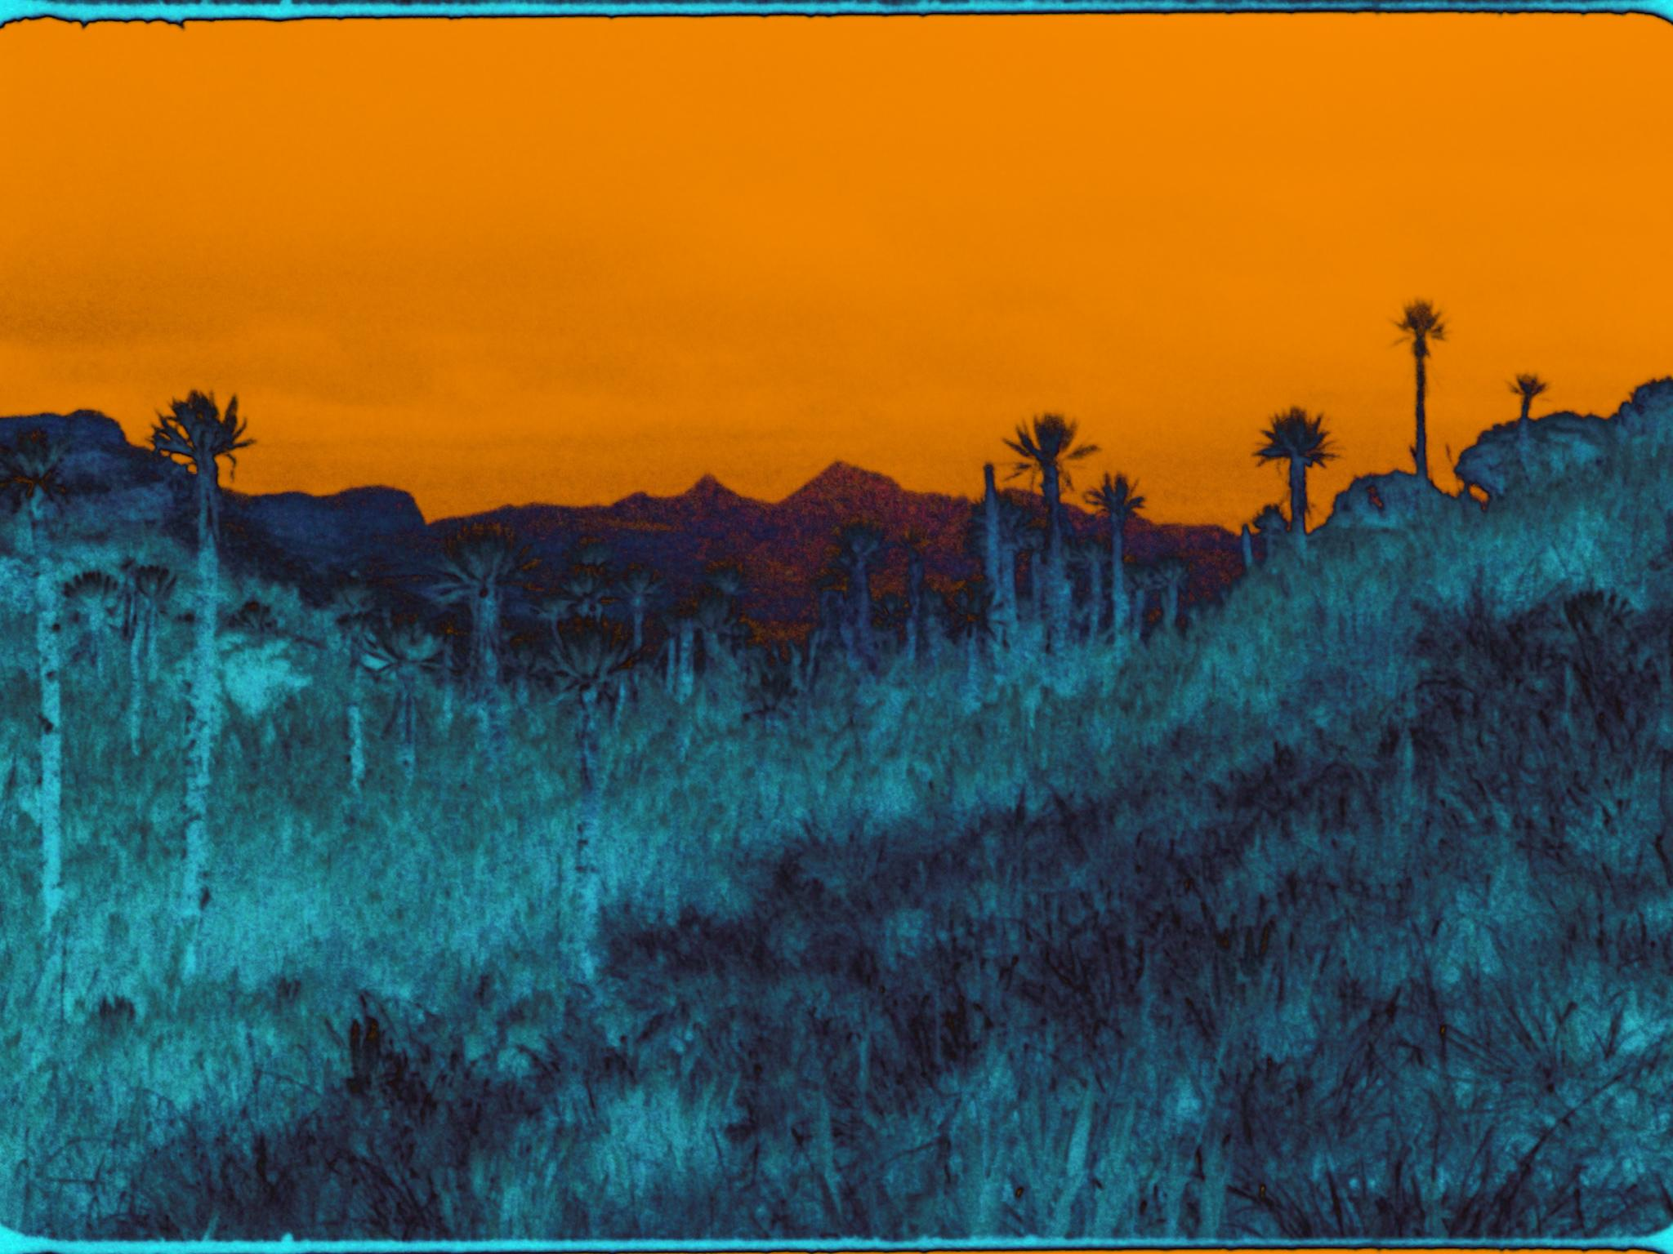

La Laguna del Soldado was shot and recorded in traditional Muisca territories near Socha, Monguí, Mongua, Villa de Leyva, Ráquira, Tutazá, Susacón, Paz de Río and the Páramo de Pisba, Ocetá, Guacheneque, Chingaza and Siscunsí in the months of January and August of 2022, and March of 2023.

“My Delirium on Chimborazo”, written by Simón Bolívar in 1822
was read by Camilo Restrepo in 2023.

All text and stills copyright Pablo Alvarez Mesa - 2024

Arturo Escobar, “Thinking-feeling with the Earth: Territorial Struggles and the Ontological Dimension of the Epistemologies of the South,” Revista de Antropología Iberoamericana 11, no. 1 (January–April 2016): 11–32, doi:10.11156/aibr.110102e.
Astrida Neimanis, “We Are All at Sea: Practice, Ethics, and Poetics of ‘Hydrocommons,’” RIBOCA2—2nd Riga International Biennial of Contemporary Art 2020, Mousse, November 17, 2020, https://www.moussemagazine.it/magazine/astrida-neimanis-sofia-lemos-2020/.
Christina Sharpe, In the Wake: On Blackness and Being (Durham, NC: Duke University Press, 2016).
Ariella Aïsha Azoulay, Potential History: Unlearning Imperialism (New York: Verso, 2019), 143.
Neimanis, “Bodies of Water,” 178.
See Eduardo Viveiros de Castro, “Perspectival Anthropology and the Method of Controlled Equivocation,” Tipití: Journal of the Society for the Anthropology of Lowland South America 2, no. 1 (June 1, 2004): 6.
Marisol de la Cadena, “Uncommoning Nature,” e-flux 65, May 2015, https://www.e-flux.com/journal/65/336365/uncommoning-nature/.

